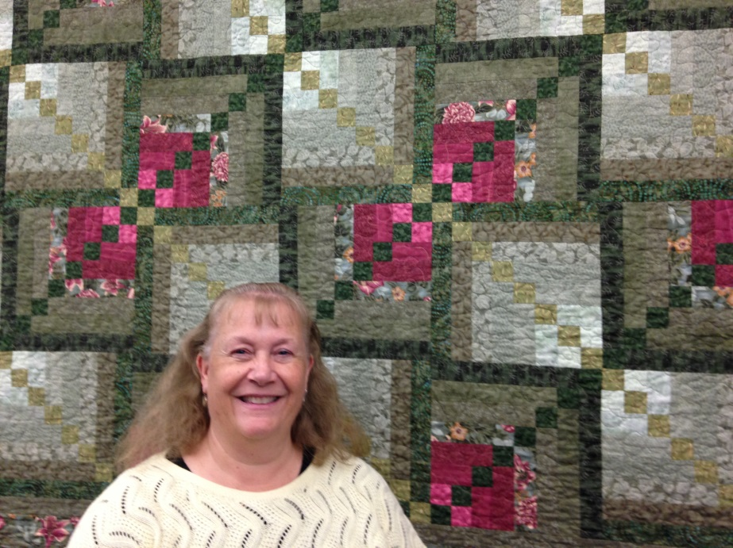
Cathy Yasick
Featured Mazomanie quilter
Mazomanie Free Library
102 Brodhead St.
Mazomanie, WI 53560

Hours: Mon.-Thurs. 10-2 & 2-7
Fri. 10-5, Sat. 10-1
608-795-2104
Show runs through August

Hi, my name is Cathy Yasick! I have been sewing since I was 9 years old. I learned when I was in 4-H and have loved sewing ever since. I started with easy clothing items and worked up to pillows and valances for my room. I learned on a treadle sewing machine that my dad bought at an auction for $5.00. I used that machine until I was in high school when my dad bought us an electric sewing machine. I had to share with my sisters, but it wasn’t bad. I loved sewing!
Shortly after I got married I bought a used machine for myself and started mending with it and before long I was decorating the house with curtains and pillows that I made. I made baptism gowns and 1st Communion dresses along with clothing items for the kids. Then when my youngest was born, Eileen Walker gave him a cute baby quilt that he still has to this day! (He is 24 years old) and later that month, my mother-in-law gave us a queen size quilt for our bed and I loved it. These quilts got me thinking that I should give quilting a try! The next summer I signed up for a chop suey class that Selma Bennett was teaching and I was hooked! That first quilt is hanging over the computer here at the library. The fabric has faded, but my love for sewing has not. That was 1992 and I can’t tell you how many quilts I have made since then! I followed that one with a baby quilt for my new god-daughter and have been making them as gifts ever since! I am currently making a wedding gift for my nephew who is getting married in July this year.
Each of my 3 boys got a quilt when they started Kindergarten instead of the plastic mat that the other kids had. I have made each of them a new quilt when they went off to college and made several for family members. I have made about a dozen raffle quilts over the years and have used quilting as a way to show people I care.
I hope you enjoy the quilts on the walls in this library as much as I have enjoyed making them.

